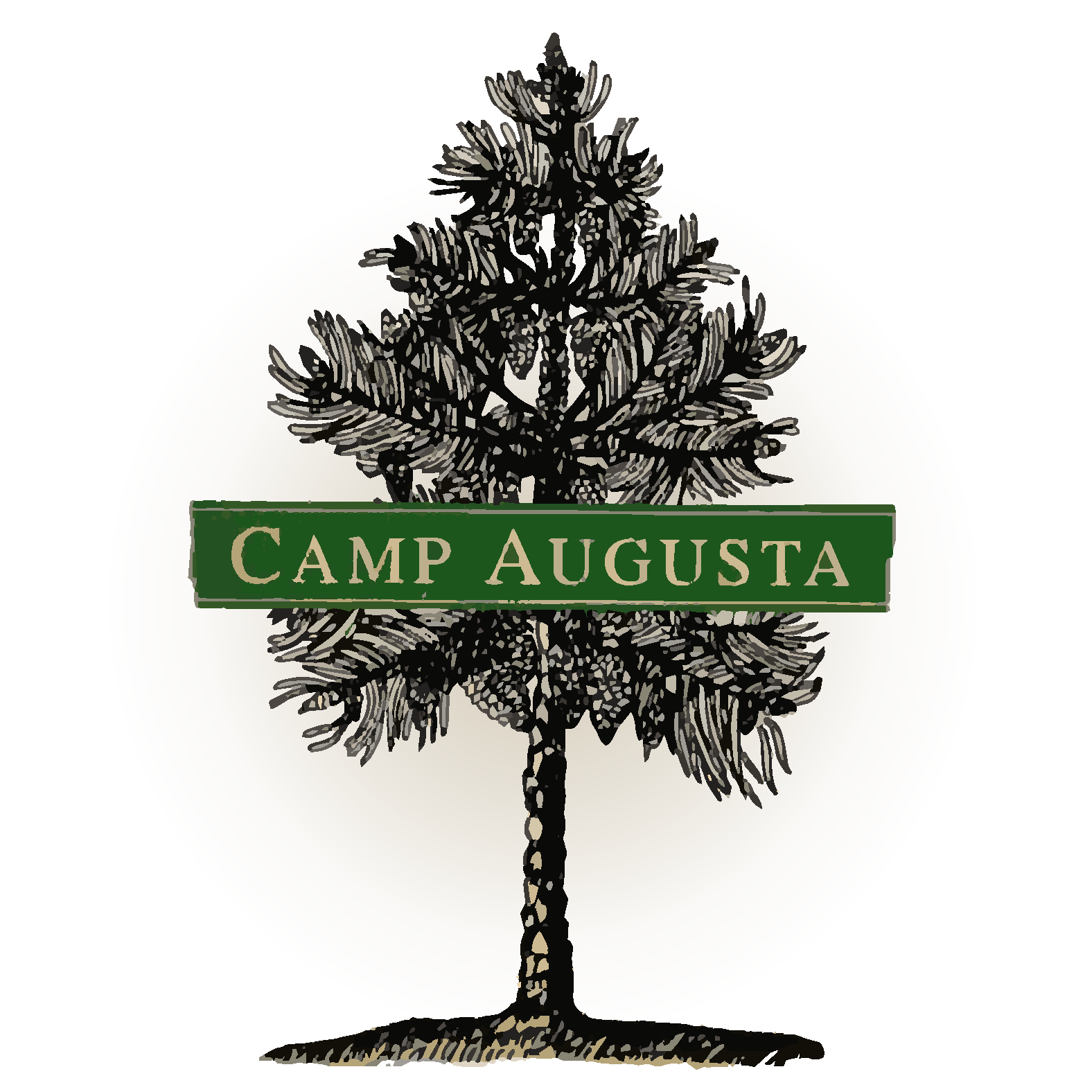
PERMISSION TO PARTICIPATE
**This form must be completed prior to starting the 2019 CIRCLE Program application. Once you have read through the CIRCLE Parent/Applicant Handbook and the Signature & Initial Form, finish off the paperwork with this form. :)

CIRCLE Applicant name: ___________________________________________________________

CIRCLE Applicant email address: ___________________________________________________

Parent name: ____________________________________________________________________

Parent email address:______________________________________________________________

**Parent/Guardian of the CIRCLE applicant, please sign below to indicate that you have read the Camp Augusta CIRCLE Parent/Applicant Handbook and the Signature & Initial Form in full, and that you grant your permission for your child to participate in the application process of the CIRCLE program.

**CIRCLE applicants please sign that you, too, have read the CIRCLE Parent/Applicant Handbook and the Signature & Initial Form with your parent/guardian and that you understand the scope and expectations of the CIRCLE program. Thank you!

Parent/Guardian
I have read the CIRCLE Handbook and understand that acceptance into the 2019 CIRCLE Program is through selective admission and give my child (the above named applicant) permission to participate in Phase One: the application process of the Camp Augusta CIRCLE Program.

________________________________________________________________________________
Parent/Guardian Signature Date

Applicant:
I have read the CIRCLE Handbook with my parent/guardian and I understand that acceptance into the 2019 CIRCLE Program is through selective admission. I am ready to participate in Phase One: the application process of the Camp Augusta CIRCLE Program

________________________________________________________________________________
CIRCLE Applicant Signature Date

