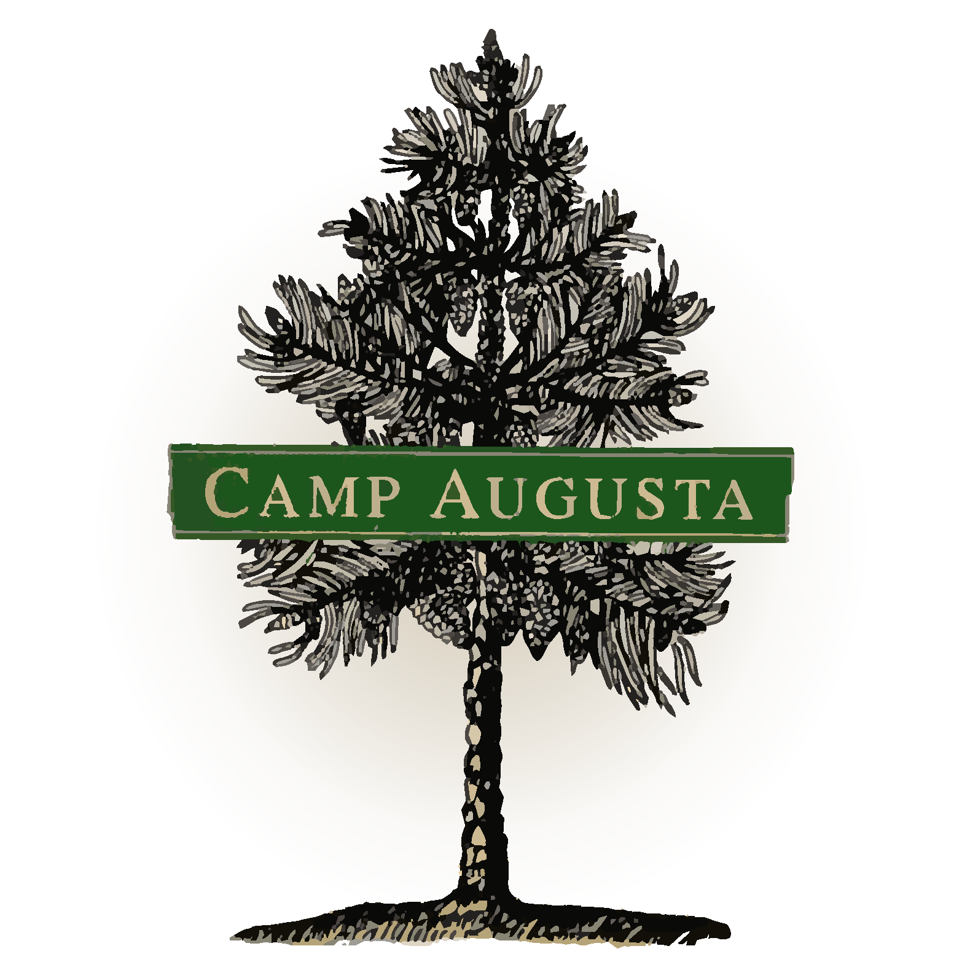
Description of the
Pre-Application and Application Processes for the CIRCLE Program
To be read by CIRCLE Applicants and Parents/Guardians

Please review this document with your camper, followed by a review of the… Key Dates for CIRCLE and CIRCLE Parent Handbook

And then sign the Signature & Initial form,as well as the Permission to Participate form.

**Please note: CIRCLE has a selective admission process**

Completing the requirements of the Phase One CIRCLE Application Process does NOT guarantee a position in Phase Two. Many campers express interest in the program, and there are only 20 available spaces. Referrals to other programs for teens will be provided for any applicants whom we do not feel are a strong fit for CIRCLE at this time, as well as thoughts about areas of growth for the future. The reason for this selective process is to foster a group culture that supports the mission of CIRCLE, and to ensure the authentic desire for the camper to take responsibility for their own experience.

TUITION: Please see the CIRCLE Tuition Breakdown document for tuition details.

Key Points Regarding Pre-Application and Application for CIRCLE
- Email, Phone, and Video Chat contact: Applicants will be in direct communication with the CIRCLE directors and other Camp Augusta staff, primarily via email, with some phone and video chat conversations. It will be necessary for your teen to have consistent weekly access to a computer and reliable internet connection to apply for and participate in CIRCLE.

- Preparation: The CIRCLE Application process requires a thorough reading of many important pages on the Camp Augusta website, campaugusta.org (over 170 pages), with notes taken on those pages and questions written down for any content that wasn’t understood.

- Intent to Apply email: Prospective applicants must send a one-paragraph email to circle@campaugusta.org stating their intent to participate with the CIRCLE application process, including their thoughts about the vision and mission of both Camp Augusta and the CIRCLE program.

Description of Phase One: The Application Process Stages
- Round 1: Essay Questions: Extensive and detailed essay answers to multiple questions will be required. Based on the effort, content, and perceived program fit from these responses, up to 18 applicants will be invited to proceed to Round 2. All applicants, whether invited to continue or not, will receive thoughtful, heartfelt feedback regarding the status of their application through each round. We recommend that applicants begin Round 1 by the end of October.

- Round 2: Essay Questions: CIRCLE staff will generate a set of follow-up questions in response to strong Round 1 answers from the applicant. Serious, thoughtful applicants typically write at least 12 pages total between the Round 1 and Round 2 questions. Up to 16 applicants will be invited to set up an interview with CIRCLE staff based upon the depth and thoughtfulness of their application thus far.

- Interview: Typically between 30-60 minutes on video chat or phone with the CIRCLE Leader, which the applicant must schedule. This will be a two-way Q&A between the CIRCLE leader and applicants who are invited to this phase of the application process, designed to get to know each other on a more personal basis before official decisions are made about entry into CIRCLE.

- Invitation or Referral: Applicants will receive an invitation to enroll in Phase Two, the Pre-Camp CIRCLE Correspondence Course, OR a referral to a different program as recommended Camp Augusta staff. We will also offer our insights into potential areas of growth for applicants who are declined admission to Phase Two.

- Accept or Decline: Applicants will have a week to reflect on the process and then accept or decline their invitation into CIRCLE. If some decline, additional spaces may be opened to other applicants. Phase Two, the pre-camp correspondence course, will begin shortly after the New Year.

Phase One Time Commitment: Up to 25 hours, spanning from mid-October through mid-December.
- Thorough reading and reflections on website content = 4+ hours
- Thorough reading of camp expectations and philosophies = 2+ hours
- Responses to application questions in Rounds One and Two = 15+ hours
- Interview = 1 hour.

